**DATABASE MANAGEMENT PRACTICE-1**

1. **Create Database dbms_practice**

CREATE DATABASE IF NOT EXISTS dbms_practice;

USE dbms_practice;

1. **Create the following tables:**
   1. **Client_master**

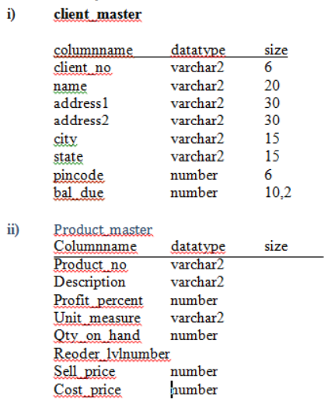

CREATE TABLE client_master(

client_no VARCHAR(6),

name VARCHAR(20),

address1 VARCHAR(30),

address2 VARCHAR(30),

city VARCHAR(15),

state VARCHAR(15),

pincode INT(6),

bal_due DECIMAL(10, 2)

);

* 1. **Product_master**



CREATE TABLE product_master(

product_no VARCHAR(20),

description VARCHAR(255),

profit_percent INT,

unit_measure VARCHAR(10),

qty_on_hand DECIMAL(10, 2),

reorder_lvl INT,

sell_price DECIMAL(10, 2),

cost_price DECIMAL(10, 2)

);

1. **Insert the following data into their respective tables:**

**Data for Client Master:**

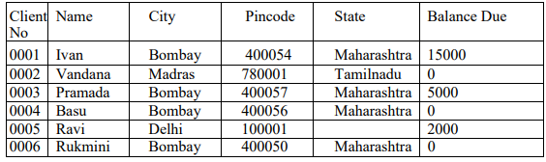

INSERT INTO client_master(client_no, name, city, pincode, state, bal_due) VALUES('0001', 'Ivan', 'Bombay', 400054, 'Maharashtra', 15000);

INSERT INTO client_master(client_no, name, city, pincode, state, bal_due) VALUES('0002', 'Vandana', 'Madras', 780001, 'Tamilnadu', 0);

INSERT INTO client_master(client_no, name, city, pincode, state, bal_due) VALUES('0003', 'Pramada', 'Bombay', 400057, 'Maharashtra', 5000);

INSERT INTO client_master(client_no, name, city, pincode, state, bal_due) VALUES('0004', 'Basu', 'Bombay', 400056, 'Maharashtra', 0);

INSERT INTO client_master(client_no, name, city, pincode, bal_due) VALUES('0005', 'Ravi', 'Delhi', 100001, 2000);

INSERT INTO client_master(client_no, name, city, pincode, state, bal_due) VALUES('0006', 'Rukmini', 'Bombay', 400050, 'Maharashtra', 0);

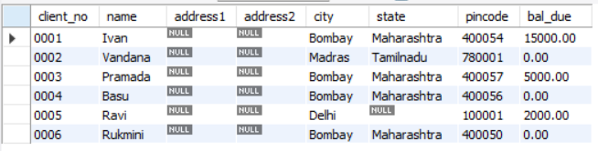

**Data for Product Master:**

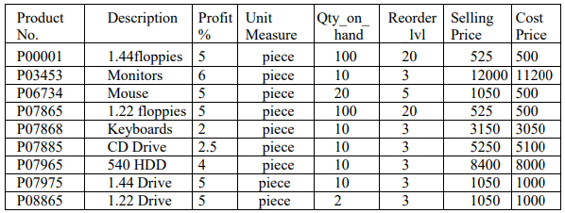

INSERT INTO product_master VALUES('P00001', '1.44floppies', 5, 'piece', 100, 20, 525, 500);

INSERT INTO product_master VALUES('P03453', 'Monitors', 6, 'piece', 10, 3, 12000, 11200);

INSERT INTO product_master VALUES('P06734', 'Mouse', 5, 'piece', 20, 5, 1050, 500);

INSERT INTO product_master VALUES('P07865', '1.22 floppies', 5, 'piece', 20, 20, 525, 500);

INSERT INTO product_master VALUES('P07868', 'Keyboards', 2, 'piece', 10, 3, 3150, 3050);

INSERT INTO product_master VALUES('P07885', 'CD Drive', 2.5, 'piece', 10, 3, 5250, 5100);

INSERT INTO product_master VALUES('P07965', '540 HDD', 4, 'piece', 10, 3, 8400, 8000);

INSERT INTO product_master VALUES('P07975', '1.44 Drive', 5, 'piece', 10, 3, 1050, 1000);

INSERT INTO product_master VALUES('P08865', '1.22 Drive ', 5, 'piece', 2, 3, 1050, 1000);

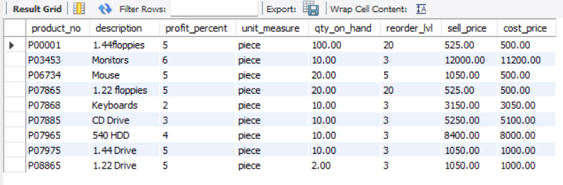

1. **On the basis of above two tables answer the following Questionries:**
2. **Find out the names of all the clients.**

SELECT name FROM client_master;

1. **Retrieve the list of names and cities of all the clients.**

SELECT name, city FROM client_master;

1. **List the various products available from the product_master table.**

SELECT DISTINCT description AS products FROM product_master;

1. **List all the clients who are located in Bombay.**

SELECT name FROM client_master

WHERE city = 'Bombay';

1. **Display the information for client no 0001 and 0002.**

SELECT * FROM client_master

WHERE client_no ='0001' OR client_no = '0002';

1. **Find the products with description as „1.44 drive‟ and „1.22 Drive‟.**

SELECT * FROM product_master

WHERE description = '1.44 Drive' OR description = '1.22 Drive';

1. **Find all the products whose sell price is greater then 5000.**

SELECT * FROM product_master

WHERE sell_price > 5000;

1. **Find the list of all clients who stay in in city „Bombay‟ or city „Delhi‟ or„Madras‟.**

SELECT name FROM client_master

WHERE city = 'Bombay' or city = 'Delhi' or city = 'Madras';

1. **Find the product whose selling price is greater than 2000 and less than or equal to 5000.**

SELECT * FROM product_master

WHERE sell_price > 2000 AND sell_price <= 5000;

1. **List the name, city and state of clients not in the state of „Maharashtra‟.**

SELECT name, city, state FROM client_master

WHERE state <> 'Maharashtra';